# CS4112/CS54111 INTRODUCTION TO DATA SCIENCE

# Exercise.1: You are required to create a data frame for the data in Table 1. In table 1 the rows denote specific days, attributes denote weather conditions on the given day, and the class denotes whether the conditions are conductive to playing golf.

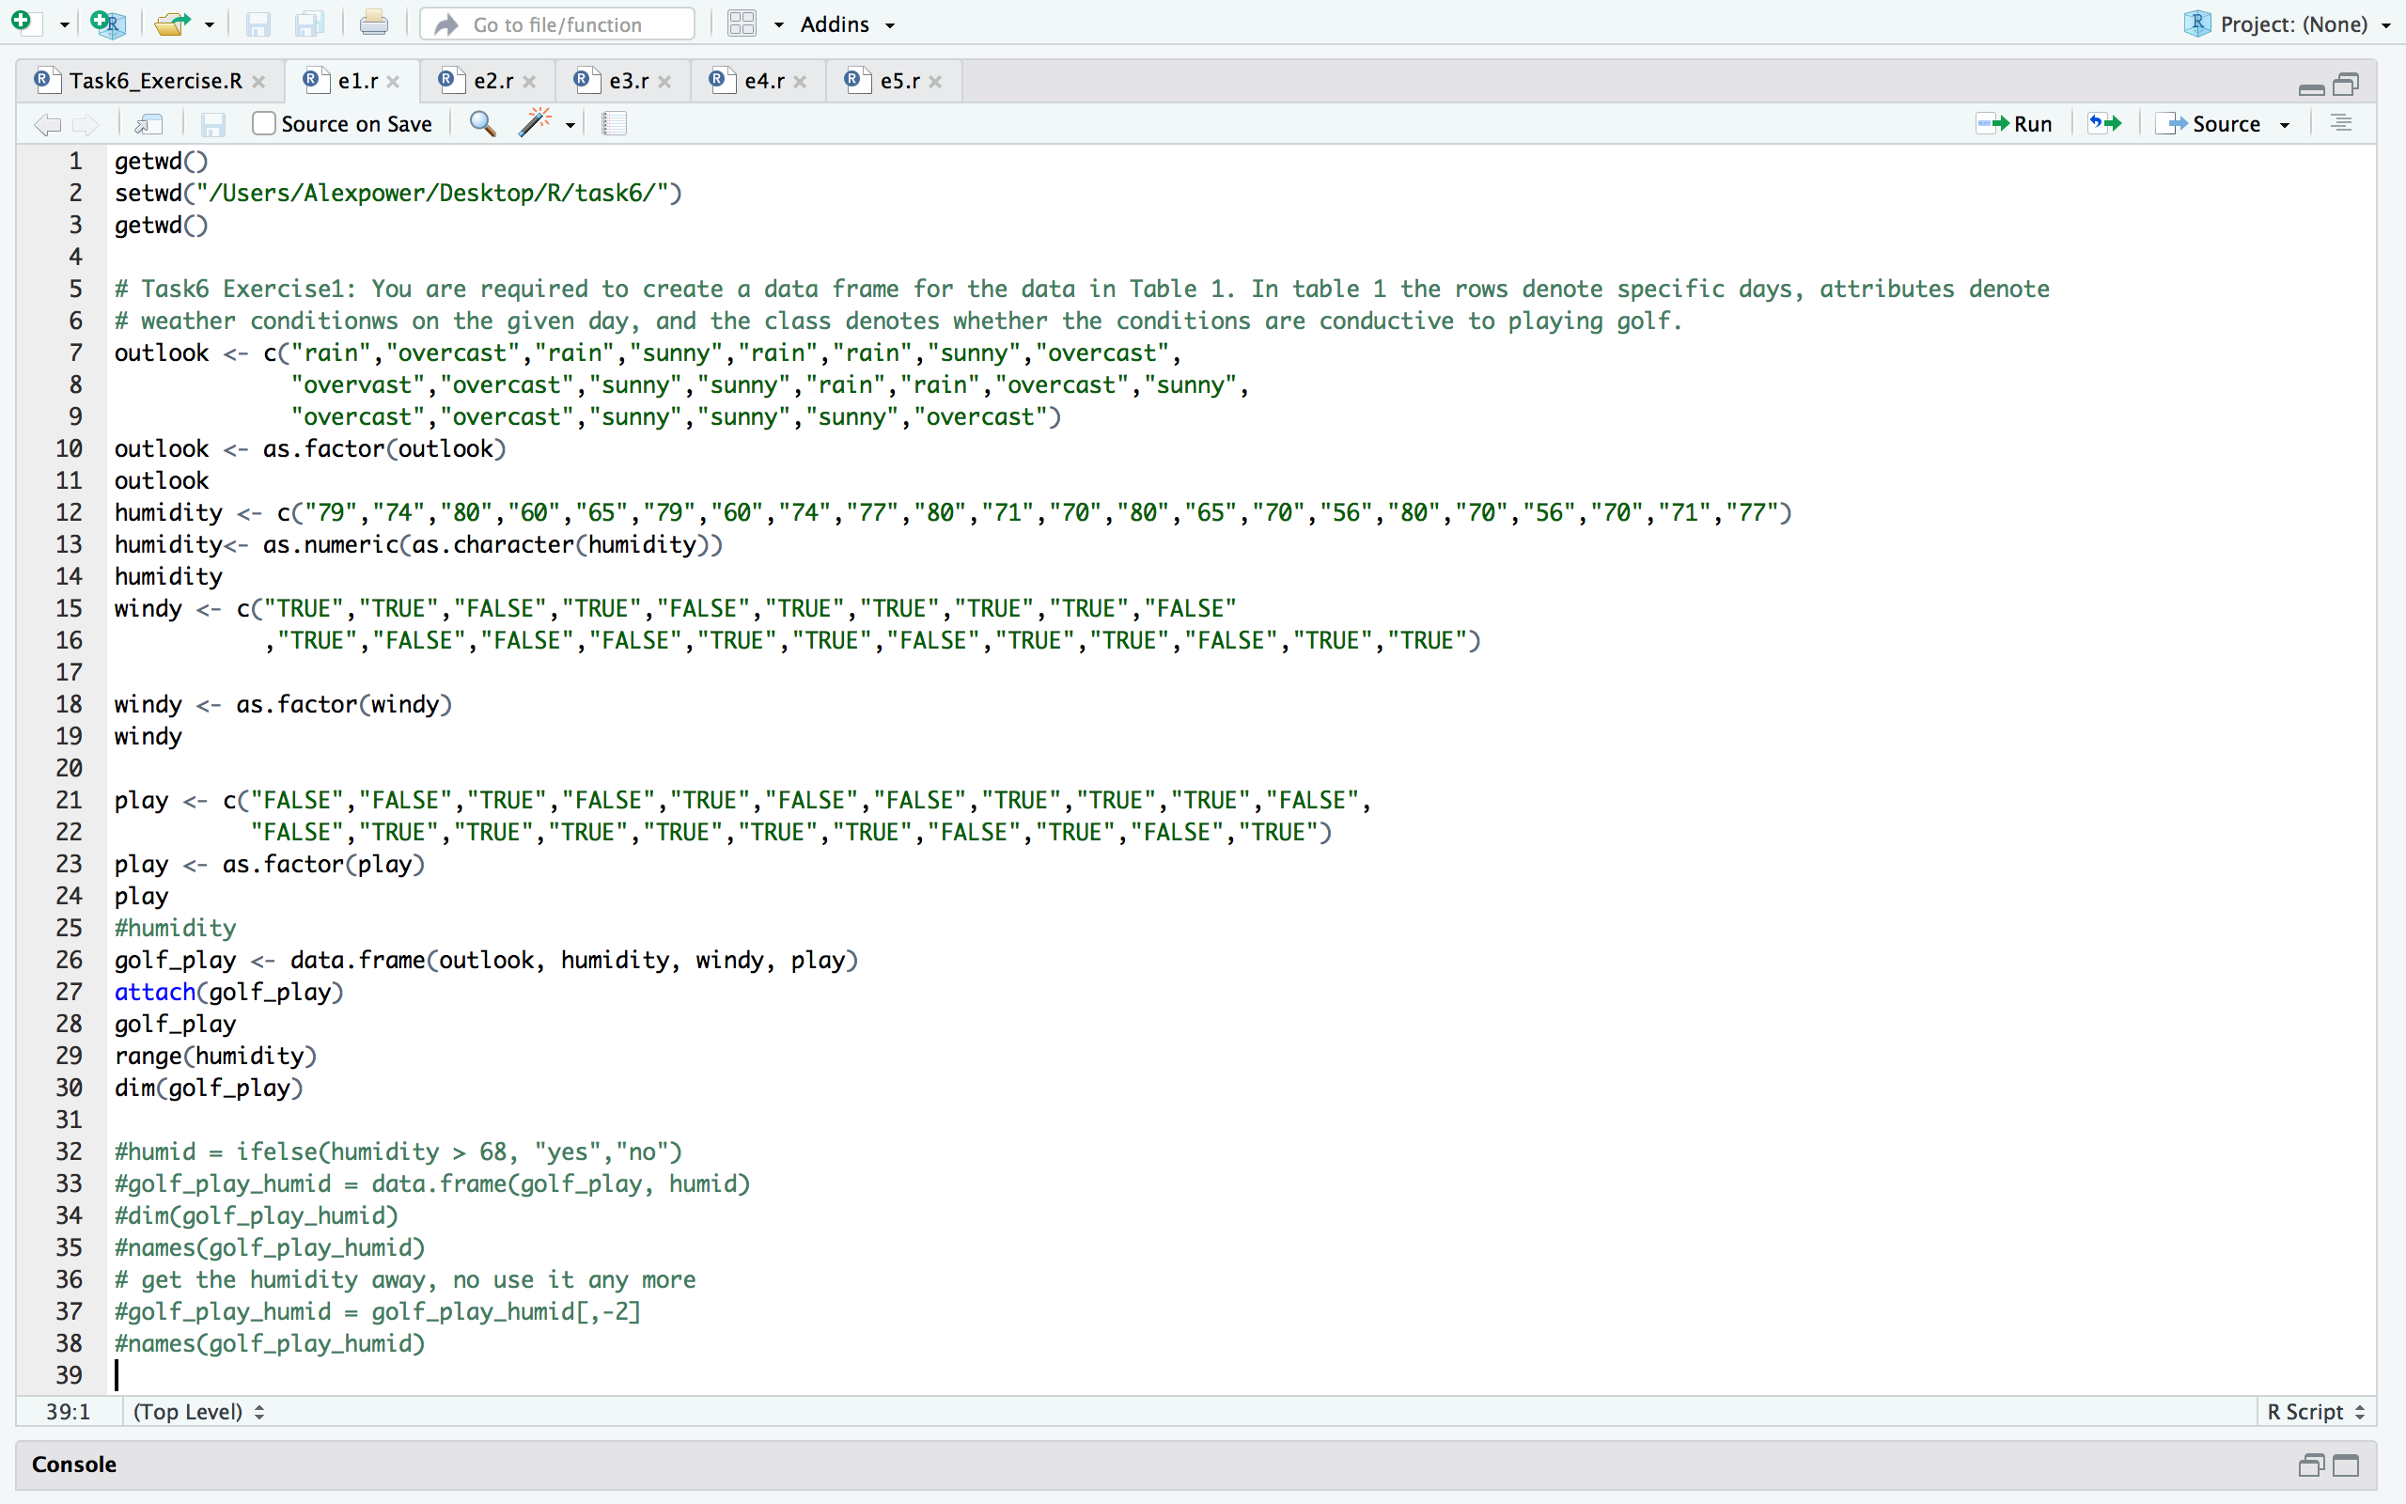

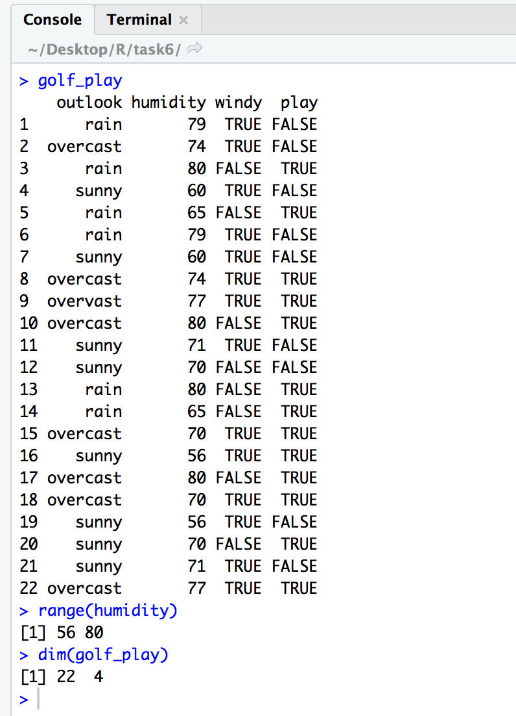

**Exercise.2:**  **You are required to construct a decision tree using the** tree package **of the play golf dataset described in Table 1.**

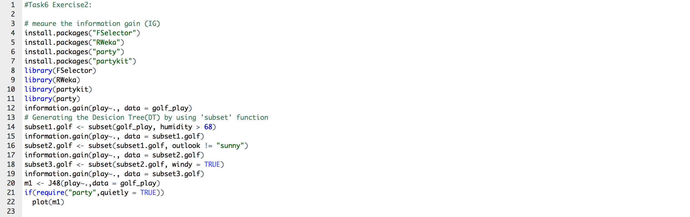



Running this code in terminal to make information.gain() available: 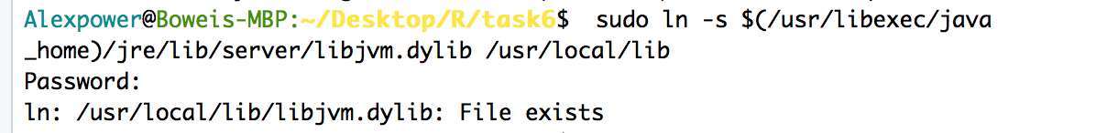

The process of getting the prediction:

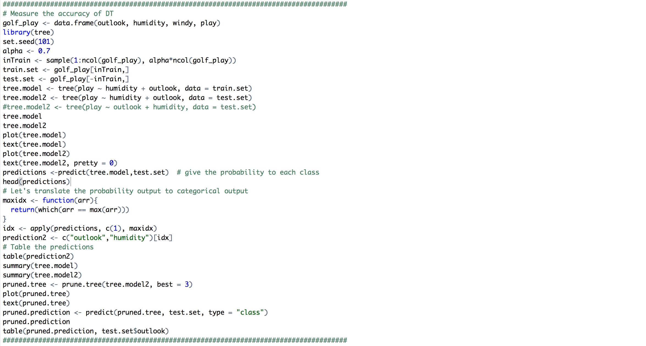

Basic DT plot:



The Pruned tree：



The prediction result from pruned tree:

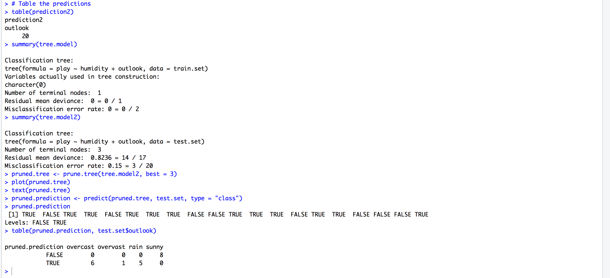

Generate Decision tree by using rpart.plot():

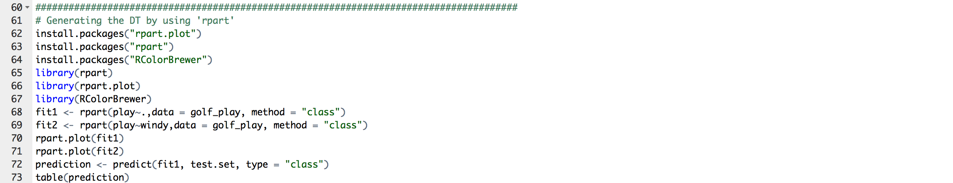

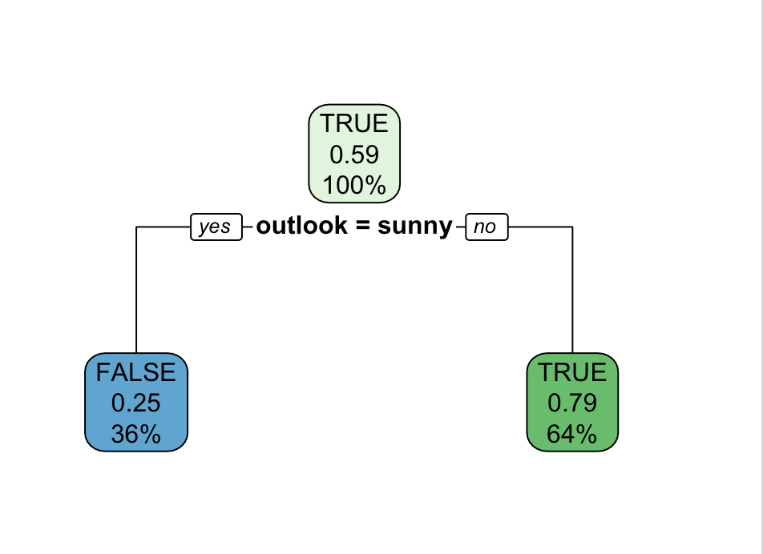

# Exercise.3.1: In this exercise you are required to use the weather data (provided by R) and construct a decision tree using the tree package to predict if it will rain tomorrow based on the today’s degree of sunshine and the degree of the cloud availability at 3pm.

The structure of this dataset can be printed as follows (note the structure will exactly inform you about the variables names at that dataset):

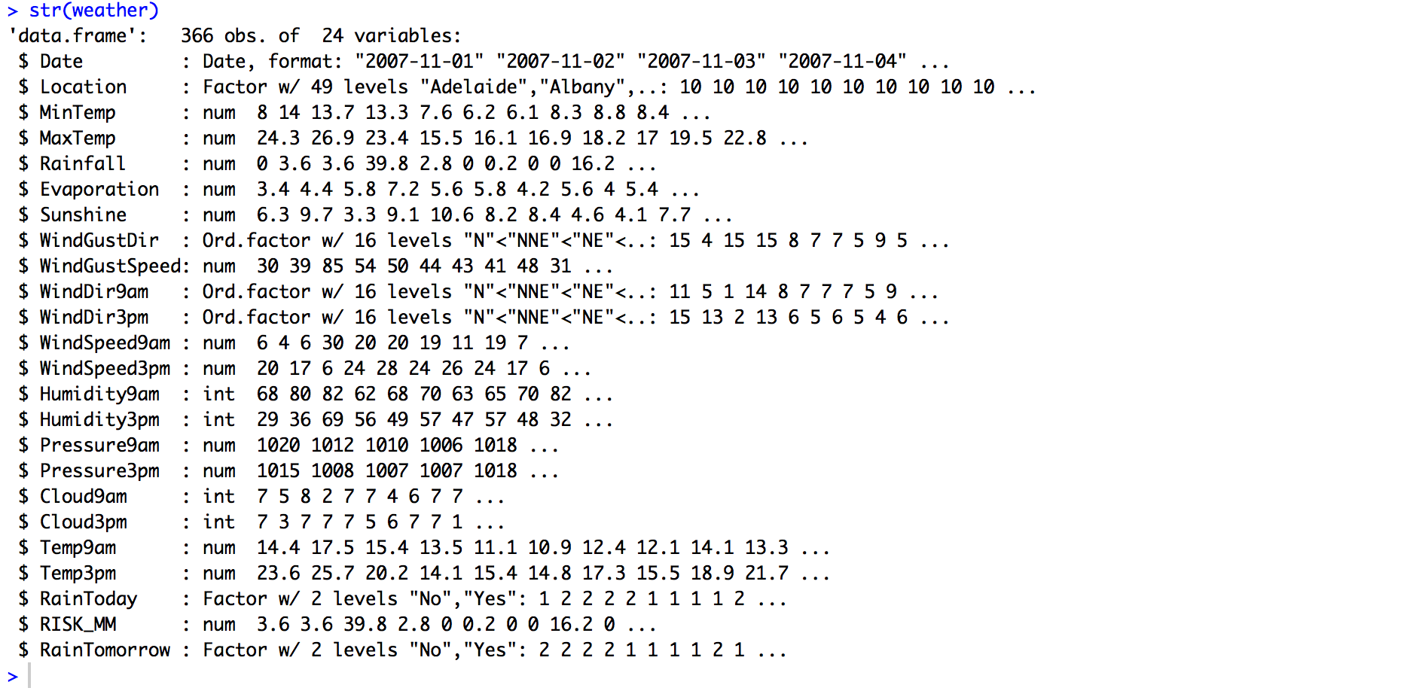

Here goes the code and explanation on the resulted DT:

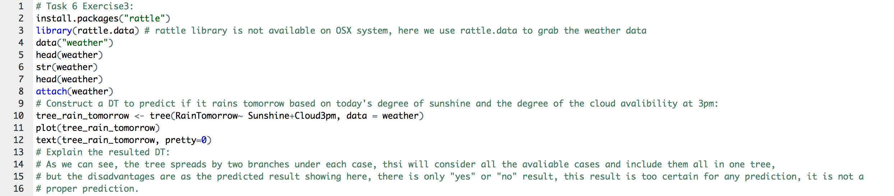



# Exercise.3.2: You are also required to change the decision tree package from tree to the ctree of the party package and generate another decision tree for the same requirement. Explain this new decision tree differences with the decision tree generated by the tree package (use comment in your code).

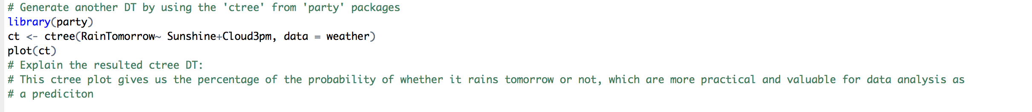







**Exercise.4: In this exercise you will use also the weather data and the ctree but you will build a decision tree for predicting if it will rain tomorrow (or not) based on the following attributes:**

* **Sunshine**
* **Pressure9am**
* **Cloud9am**





**Exercise.5: Use the decision tree generated by Exercise 4 and use the predict function on whether it will rain tomorrow or not.**

**# Then plot the predict method outcome (e.g. as a table).:**

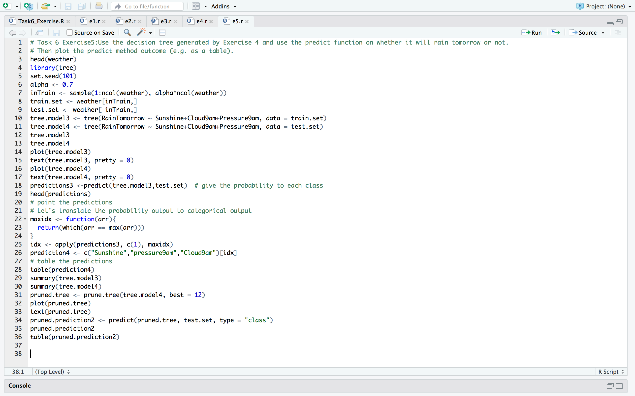

Table the predicted outcome:

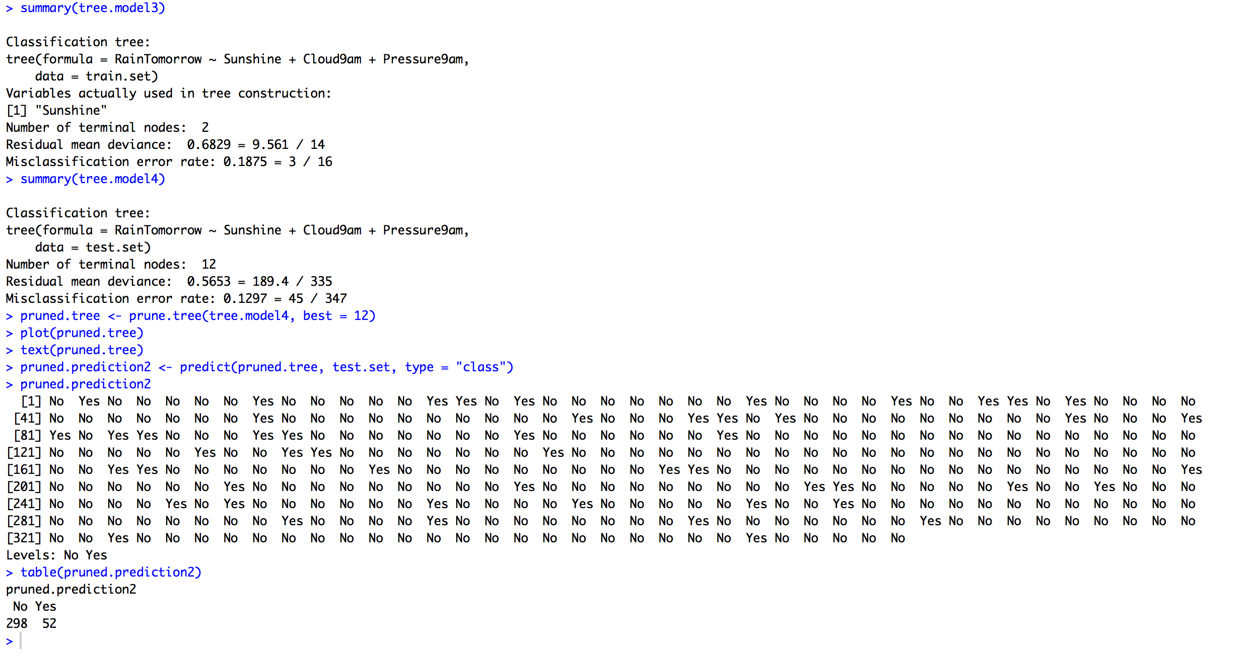

The Pruned Tree:

